**PRACTICAS REALIZADAS**

**KAFKA**

* **MICROSERVICIOS**

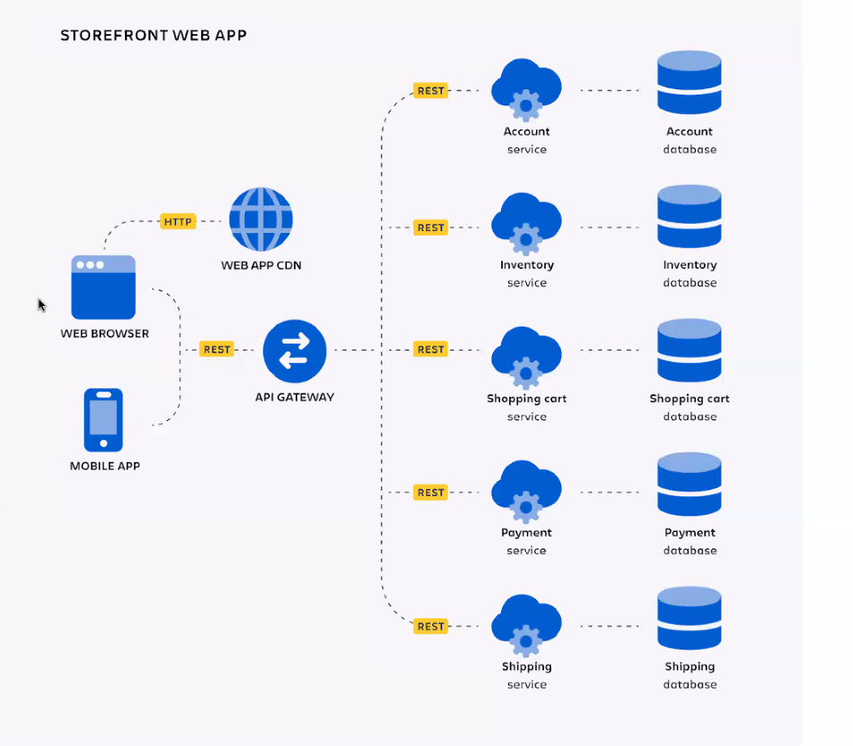

* **DOCKER**

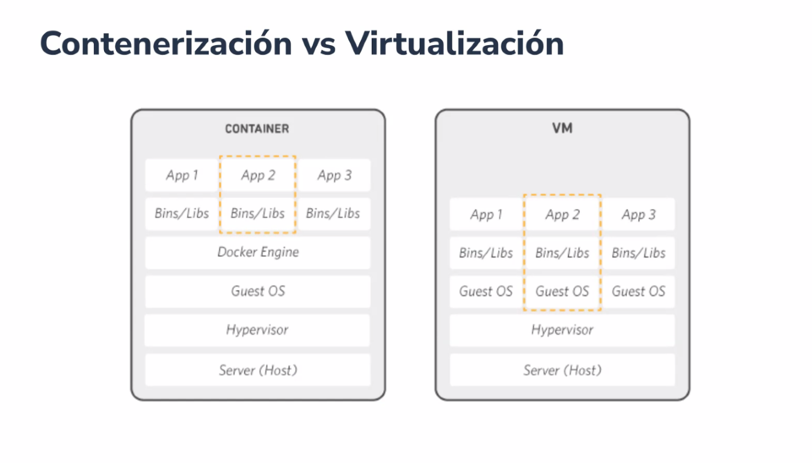

* **Inicialización Zookeeper:**

.\bin\windows\zookeeper-server-start.bat .\config\zookeeper.properties

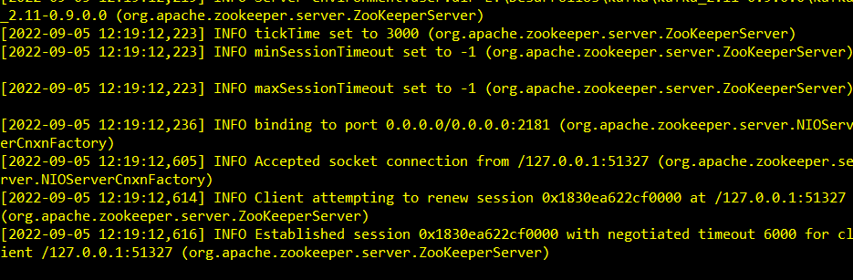

* **Kafka server:**

.\bin\windows\kafka-server-start.bat config\server.properties

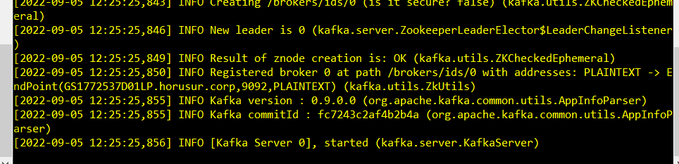

* **Creando Tópico:**

.\bin\windows\kafka-topics.bat --create --zookeeper localhost:2181 --replication-factor 1 --partitions 1 --topic test



* **Con comando:**

.\bin\windows\kafka-topics.bat --create --topic topic_demo --bootstrap-server localhost:9092



* **Escribir eventos:**

1. PRODUCER:

.\bin\windows\kafka-console-producer.bat --topic topic_demo --bootstrap-server localhost:9092

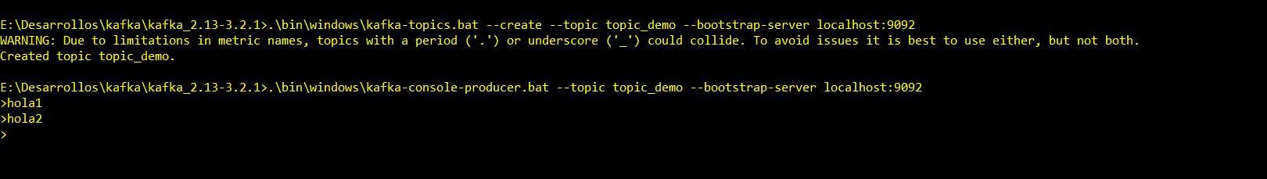

1. CONSUMER:

.\bin\windows\kafka-console-consumer.bat --topic topic_demo --from-beginning --bootstrap-server localhost:9092

